**Experiment No.8**

**Effectiveness Of Cooling Tower**

**Introduction:**

“A cooling tower is a heat rejection device, which extracts waste heat to the atmosphere though the cooling of water to a lower temperature. The general term "cooling tower" is used to describe both direct (open circuit) and indirect (closed circuit) heat rejection equipment.”

**Parts of cooling tower:**

* Water Pump
* Water filter
* Water Distributor
* Water Flow meter
* Centrifugal fan with 0.5 and 1 kw pre heater
* Air distribution chamber
* Water basin
* Tower column with packing density 110 m^2/m^3
* Manual Valve
* Float Valve
* Float Switch

**Types of Cooling Tower:**

* [Counterflow Cooling Towers](https://www.coolingtowerproducts.com/blog/how-cooling-towers-work-diagram-pictures-2015.htm#6)
* [Crossflow Cooling Towers](https://www.coolingtowerproducts.com/blog/how-cooling-towers-work-diagram-pictures-2015.htm#5)
* [Forced Draft & Induced Draft Cooling Towers Process](https://www.coolingtowerproducts.com/blog/how-cooling-towers-work-diagram-pictures-2015.htm#7)
* [Natural Draft & Fan Assisted Natural Draft Cooling Towers](https://www.coolingtowerproducts.com/blog/how-cooling-towers-work-diagram-pictures-2015.htm#8)

**Diagram:**

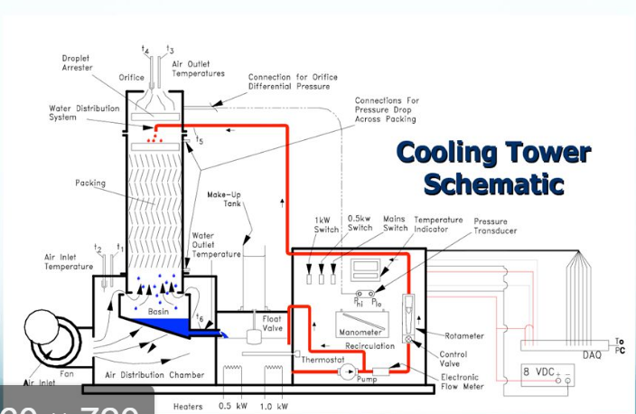

Fig no 8.1: Diagram of cooling tower

**Explanation of cooling tower working principle:**

Cooling towers are a special type of heat exchanger that allows water and air to come in contact with each other to lower the temperature of the hot water. During this process, small volumes of water evaporate, lowering the temperature of the water that’s being circulated throughout the cooling tower. In a short summary, a cooling tower cools down water that gets over heated by industrial equipment and processes.

The hot water is usually caused by air conditioning condensers or other industrial processes. That water is pumped through pipes directly into the cooling tower. Cooling tower nozzles are used to spray the water onto to the “fill media”, which slows the water flow down and exposes the maximum amount of water surface area possible for the best air-water contact. The water is exposed to air as it flows throughout the cooling tower. The air is being pulled by an motor-driven electric “cooling tower fan”.

When the air and water come together, a small volume of water evaporates, creating an action of cooling. The colder water gets pumped back to the process/equipment that absorbs heat or the condenser. It repeats the loop over and over again to constantly cool down the heated equipment or condensers.

**Evaporative Cooling:**

**Evaporative cooling** is the process where warm water from an industrial process is pumped up to the top of the cooling tower where the water distribution system is. The water then gets distributed by cooling tower nozzles to the wet deck. At the same time, air is being drawn through the air-inlet louvers forcing water to evaporate. Evaporation causes the heat to be removed from the make up water. The hot air naturally rises out of the tire.

**Formulas:**

Range=T5-T6

Approach=T6-T2

Effectiveness=Range/(Range+Approach) *100

**Table 1:**

|  |  |  |
| --- | --- | --- |
| **Measurement points** | **Measurement** | **Units** |
| Air Velocity | 6.3 | m/s |
| Water flow | 4 | Lpm |
| Air inlet temp(dry bulb)T1 | 19 | **°**C |
| Air inlet temp(wet bulb)T2 | 19 | °C |
| Air outlet temp(dry bulb)T3 | 20 | °C |
| Air outlet temp(wet bulb)T4 | 22 | °C |
| Cooling Tower water inletT5 | 23 | °C |
| Cooling Tower water outlet T6 | 19 | °C |
| Make up water temp T7 | 13 | °C |

**From Table 1:**

Range=23-19

=4°C

Approach=19-19=0°C

Effectiveness=4/4+0*100

=100%

**Table 2:**

|  |  |  |
| --- | --- | --- |
| **Measurement points** | **Measurement** | **Units** |
| Air Velocity | 8.4 | m/s |
| Water flow | 6 | Lpm |
| Air inlet temp(dry bulb)T1 | 13 | **°**C |
| Air inlet temp(wet bulb)T2 | 13 | °C |
| Air outlet temp(dry bulb)T3 | 18 | °C |
| Air outlet temp(wet bulb)T4 | 19 | °C |
| Cooling Tower water inletT5 | 20 | °C |
| Cooling Tower water outlet T6 | 17 | °C |
| Make up water temp T7 | 13 | °C |

**From Table 2:**

Range=20-17

=3°C

Approach=17-13

=4°C

Effectiveness=3/4+3*100

=42.86%

**Applications:**

* Tradional HVAC heating and cooling systems are used in schools, large office buildings, and hospital.
* On the other hand, Cooling towers are much larger than tradional HVAC systems and are used to remove heat from cooling tower water systems in petroleum refineries, plants, natural gas processing plants, petrochemical plants, and other industrial processes and facilities

**Heat Exchanger:**

A **heat exchanger** is a system used to transfer heat between two or more [fluids](https://en.m.wikipedia.org/wiki/Fluid). Heat exchangers are used in both cooling and heating processes. The fluids may be separated by a solid wall to prevent mixing or they may be in direct contact.

**Uses:**

They are widely used in [space heating](https://en.m.wikipedia.org/wiki/Space_heating), [refrigeration](https://en.m.wikipedia.org/wiki/Refrigeration), [air conditioning](https://en.m.wikipedia.org/wiki/Air_conditioning), [power stations](https://en.m.wikipedia.org/wiki/Power_station), [chemical plants](https://en.m.wikipedia.org/wiki/Chemical_plant), [petrochemical plants](https://en.m.wikipedia.org/wiki/Petrochemical), [petroleum refineries](https://en.m.wikipedia.org/wiki/Oil_refinery), [natural-gas processing](https://en.m.wikipedia.org/wiki/Natural-gas_processing), and [sewage treatment](https://en.m.wikipedia.org/wiki/Sewage_treatment)